**Praktikum 4**

**ANALISIS REGRESI BERGANDA**

Dalam praktikum ini akan dipelajari dan dipraktekkan bagaimana melakukan pemodelan linier serta pengujian asumsi menggunakan beberapa library di bawah ini.

> library(olsrr)

> library(car)

> library(lmtest)

> library(ggpubr)

#### Regresi Linier Sederhana

Pada regresi linier akan dibicarakan masalah pendugaan atau peramalan sebuah variabel dependen Y dengan sebuah variabel independen X yang telah diketahui nilainya. Model persamaan linier yang digunakan di sini adalah : .

Nilai a dan b dapat diperoleh dari rumus :



dan



**Data latihan : Housepices.csv**

|  |
| --- |
| > library(RMySQL)  > con = dbConnect(MySQL(), user = 'root', password = '', dbname =  + 'db_iris', host = 'localhost')  > myQuery <- "select * from iris;"  > df <- dbGetQuery(con, myQuery)  > View(df) |

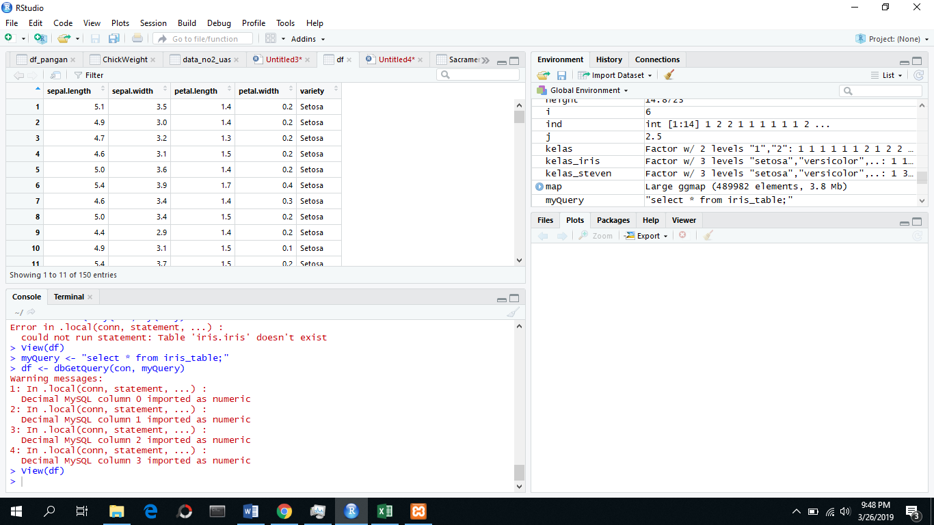

|  |
| --- |
| > relasi = lm(df$petal.length ~ df$sepal.length)  > relasi  Call:  lm(formula = df$petal.length ~ df$sepal.length)  Coefficients:  (Intercept) df$sepal.length  -7.101 1.858 |

**Data latihan : DirectMarketing.csv**

|  |
| --- |
| > library(RMySQL)  > con = dbConnect(MySQL(), user = 'root', password = '', dbname ='direct_marketing', host = 'localhost')  > myQuery <- "select * from direct_marketing;"  > DirectMarketing <- dbGetQuery(con, myQuery)  > View(df) |

|  |
| --- |
| > regresi = lm (DirectMarketing$AmountSpent ~ DirectMarketing$Salary)  > regresi  Call:  lm(formula = DirectMarketing$AmountSpent ~ DirectMarketing$Salary)  Coefficients:  (Intercept) DirectMarketing$Salary  -15.31783 0.02196  > summary(regresi)  Call:  lm(formula = DirectMarketing$AmountSpent ~ DirectMarketing$Salary)  Residuals:  Min 1Q Median 3Q Max  -2179.7 -315.2 -53.5 279.7 3752.9  Coefficients:  Estimate Std. Error t value Pr(>|t|)  (Intercept) -15.31783 45.37416 -0.338 0.736  DirectMarketing$Salary 0.02196 0.00071 30.930 <2e-16 ***  ---  Signif. codes: 0 ‘***’ 0.001 ‘**’ 0.01 ‘*’ 0.05 ‘.’ 0.1 ‘ ’ 1  Residual standard error: 687.1 on 998 degrees of freedom  Multiple R-squared: 0.4894, Adjusted R-squared: 0.4889  F-statistic: 956.7 on 1 and 998 DF, p-value: < 2.2e-16 |

**Data latihan : mtcars.csv**

|  |
| --- |
| >data(mtcars) #memanggil data mtcars  >View(mtcars) #melihat data mtcars  > plot(mpg ~ wt, data=mtcars) # membuat plot regresi |

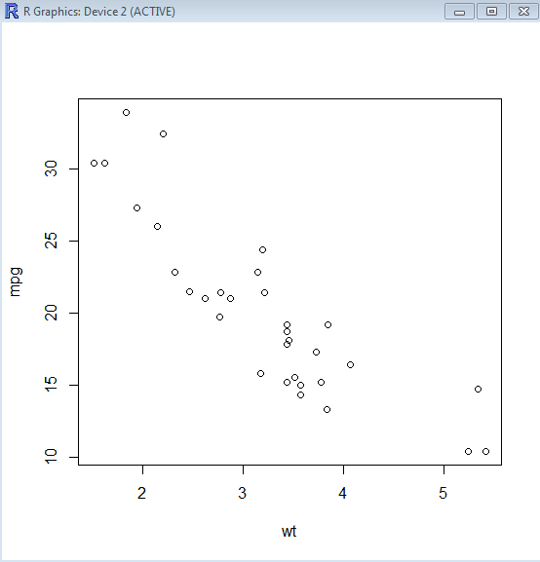

|  |
| --- |
| > model <- lm(mpg ~ wt, data=mtcars) #membuat model regresi  > abline(model) # membuat garis pada plot regresi |

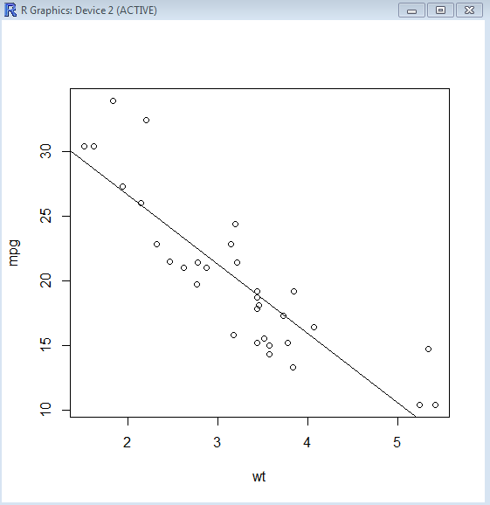

|  |
| --- |
| > summary(model) #melihat model regresi |

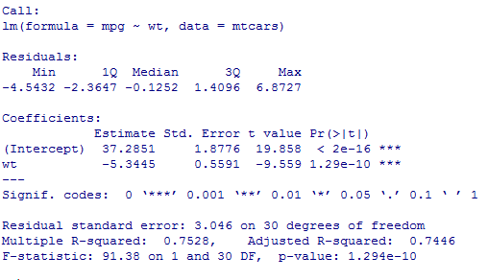

|  |  |
| --- | --- |
|  |  |
|  | |

|  |
| --- |
| > predict(model, newdata=data.frame(wt=6)) #misalkan nilai wt adalah 6 maka hasil prediksinya adalah |



> ggscatter(mtcars, x = "mpg", y = "wt",

add = "reg.line", conf.int = TRUE,

cor.coef = TRUE, cor.method = "pearson")

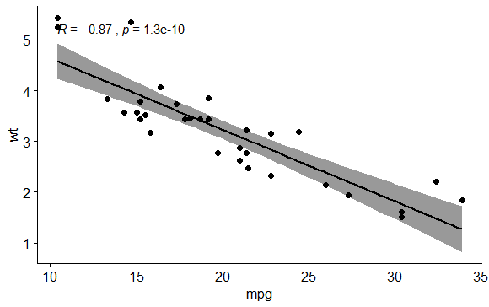

**Uji Asumsi**

1. **Normalitas**

Uji normalitas dilakukan untuk melihat apakah nilai residual berdistribusi normal atau tidak.

#> ols_rsd_qqplot(model)

> ols_plot_resid_qq(model)

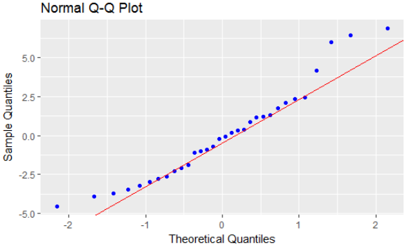

> ols_test_normality(model)

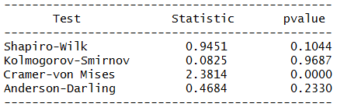

|  |
| --- |
| > par(mfrow=c(2,2))  > model <- lm(mpg ~ wt, data=mtcars)  > plot(model) |

1. **Heteroskedastisitas**

Uji heteroskedastisitas digunakan untuk melihat apakah terdapat ketidaksamaan varian dari residual satu pengamatan ke pengamatan yang lain.

jumlah koefisien (termasuk konstanta) atau Obs*R-

squared < α, maka hipotesis nol yang menyatakan adanya homoskedastitas

ditolak.

H0: ${σ_{1}}^{2}$ = ${σ_{1}}^{2}$ =… = ${σ_{N}}^{2}$ = ${σ_{ε}}^{2}$ = $σ^{2}$ (Ragam sisaan homogen)

H1: ${σ_{i}}^{2}$ = c ${X_{i}}^{2}$ (Ragam sisaan tidak homogen atau heterogen)

> lmtest::bptest(model)

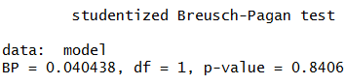

1. **Autokorelasi**

Untuk lebih meyakinkan, akan dilakukan pengujian hipotesis dengan statistik uji *Durbin-Watson*, sebagai berikut.

Hipotesis:

$H_{0}$: $ρ=0$ (tidak ada autokorelasi)

$H_{1}$: $ρ≠0$ (ada autokorelasi)

-Taraf signifikansi : $α=0.05$

-Statistik uji:

$$d=\frac{\sum_{t=2}^{n}{{(e_{t}-e_{t-1})}^{2}}}{\sum_{i=1}^{n}{{e_{t}}^{2}}}$$

> dwtest(model)

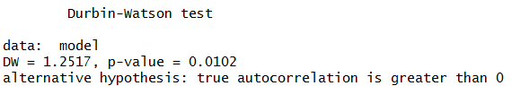

**ols_rsd_hist**(model)

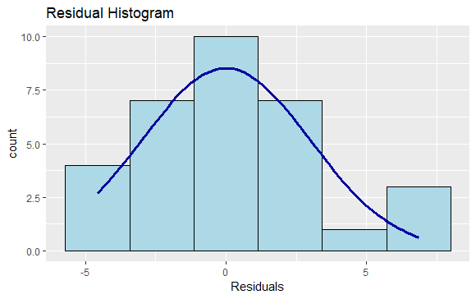

#### Regresi Linier Berganda

Jika variabel dependen-nya dihubungkan dengan lebih dari satu variabel independen, maka persamaan yang dihasilkan adalah persamaanregresi linier berganda (*multiple linier regression*). Dalam hal ini kita membatasi pada kasus dua peubah bebas X1 dan X2 saja. Dengan hanya dua peubah bebas, persamaan regresi contohnya menjadi :



Salah satu ukuran kebaikan model adalah dengan melihat koefisien determinasi R2 yang menyatakan proporsi keragaman variabel Y yang dapat dijelaskan oleh variabel X. Namun penggunaan yang lebih baik adalah dengan menggunakan nilai **R-Sq(adj)**, yang merupakan nilai estimasi yang tidak bias (*unbiased estimate*) dari populasi.

|  |
| --- |
| > data("mtcars")  > model=lm(mpg ~ am + wt + hp, data = mtcars)  > summary(model) |

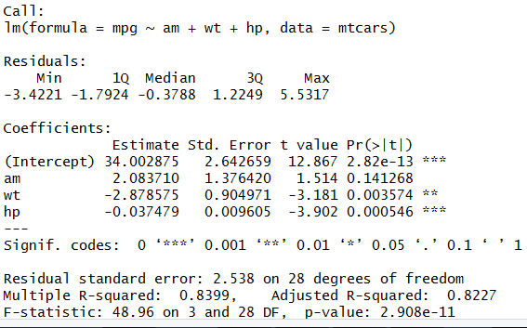

**Pada output diatas tedapat variabel yang tidak signifikan…maka variabel tersebut jangan langsung dibuang. Lakukanlah explorasi data.**

|  |
| --- |
| > hist(mtcars$am)  > plot(mpg~am,data=mtcars) |
| Melihat Korelasi Antar Variabel  > dataku=mtcars[,c(1,4,6,9)]  > cor(dataku,method = "pearson") |
| |  | | --- | |  | |

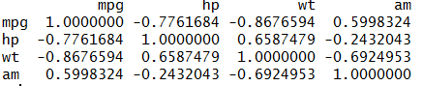

> ols_correlations(model)

Correlations

-------------------------------------------

Variable Zero Order Partial Part

-------------------------------------------

am 0.600 0.275 0.114

wt -0.868 -0.515 -0.241

hp -0.776 -0.593 -0.295

-------------------------------------------

**Zero Order**

Pearson correlation coefficient between the dependent variable and the independent variables.

**Part**

Unique contribution of independent variables. How much R2R2 will decrease if that variable is removed from the model?

**Partial**

How much of the variance in **Y**, which is not estimated by the other independent variables in the model, is estimated by the specific variable?

**UJI ASUMSI**

1. **Normalitas**

> ols_rsd_qqplot(model)

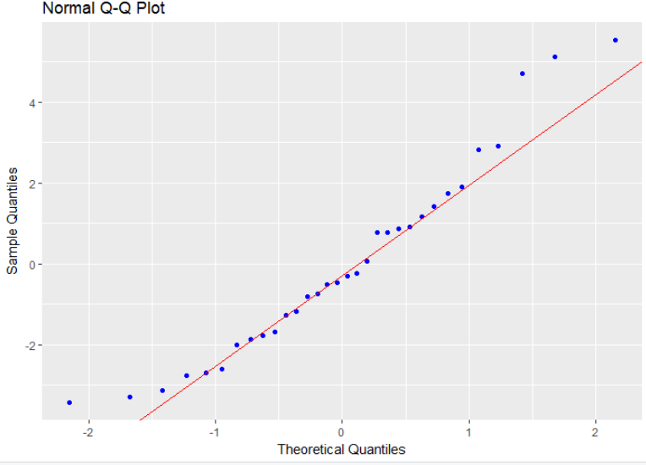

> ols_norm_test(model)

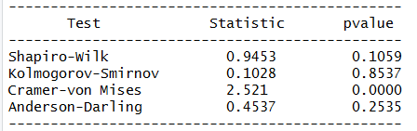

1. **Heteroskedastisitas**

H0: ${σ_{1}}^{2}$ = ${σ_{1}}^{2}$ =… = ${σ_{N}}^{2}$ = ${σ_{ε}}^{2}$ = $σ^{2}$ (Ragam sisaan homogen)

H1: ${σ_{i}}^{2}$ = c ${X_{i}}^{2}$ (Ragam sisaan tidak homogen atau heterogen)

> lmtest::bptest(model)

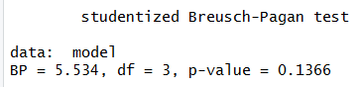

1. **Autokorelasi**

Untuk lebih meyakinkan, akan dilakukan pengujian hipotesis dengan statistik uji *Durbin-Watson*, sebagai berikut.

Hipotesis:

$H_{0}$: $ρ=0$ (tidak ada autokorelasi)

$H_{1}$: $ρ≠0$ (ada autokorelasi)

-Taraf signifikansi : $α=0.05$

-Statistik uji:

$$d=\frac{\sum_{t=2}^{n}{{(e_{t}-e_{t-1})}^{2}}}{\sum_{i=1}^{n}{{e_{t}}^{2}}}$$

> dwtest(model)

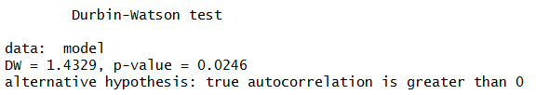

1. **MULTICOLONIERITAS**

> ols_vif_tol(model)

# A tibble: 3 x 3

Variables Tolerance VIF

*<chr>* *<dbl>* *<dbl>*

1 am 0.440 2.27

2 wt 0.265 3.77

3 hp 0.479 2.09

Dapat dilihat pada hasil output diatas diketahui bahwa nilai VIF dari masing-masing variabel kurang dari 5 maka dapat dikatakan tidak terjadi multikolinieritas.

<https://cran.r-project.org/web/packages/olsrr/vignettes/regression_diagnostics.html>

**Tugas : Advertising.csv**

*Data is about advertising data sales (in thousands of units) for a particular product advertising budgets (in thousands of dollars) for TV, radio, and newspaper media. On the basis of this data,suggest a marketing plan for next year that will result in high product sales using regression analysis. Please also test the assumptions.*

<https://rstudio-pubs-static.s3.amazonaws.com/249959_d71491a56f8242909331dfee0e25b813.html>

> Advertising<-read.csv("D:/Semester 6/Data analitik/Praktikum/prak4/Advertising.csv",head=TRUE)[,-1]

> wd <- getwd()

> file <- paste(wd,"Advertising.csv",sep="/")

> Advertising<-read.csv(file, head=TRUE)[,-1]

> head(Advertising)

TV Radio Newspaper Sales

1 230.1 37.8 69.2 22.1

2 44.5 39.3 45.1 10.4

3 17.2 45.9 69.3 9.3

4 151.5 41.3 58.5 18.5

5 180.8 10.8 58.4 12.9

6 8.7 48.9 75.0 7.2

> summary(Advertising)

TV Radio Newspaper Sales

Min. : 0.70 Min. : 0.000 Min. : 0.30 Min. : 1.60

1st Qu.: 74.38 1st Qu.: 9.975 1st Qu.: 12.75 1st Qu.:10.38

Median :149.75 Median :22.900 Median : 25.75 Median :12.90

Mean :147.04 Mean :23.264 Mean : 30.55 Mean :14.02

3rd Qu.:218.82 3rd Qu.:36.525 3rd Qu.: 45.10 3rd Qu.:17.40

Max. :296.40 Max. :49.600 Max. :114.00 Max. :27.00

> pairs(Advertising, pch=".")

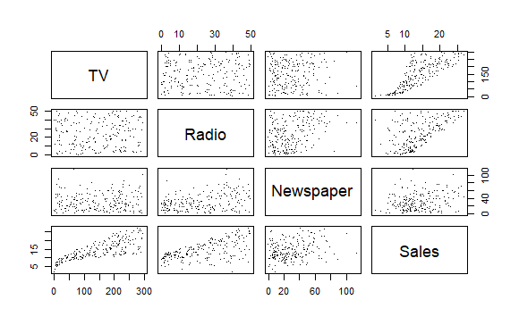

> ad.lm <- lm(Sales~., data=Advertising)

> summary(ad.lm)

Call:

lm(formula = Sales ~ ., data = Advertising)

Residuals:

Min 1Q Median 3Q Max

-8.8277 -0.8908 0.2418 1.1893 2.8292

Coefficients:

Estimate Std. Error t value Pr(>|t|)

(Intercept) 2.938889 0.311908 9.422 <2e-16 ***

TV 0.045765 0.001395 32.809 <2e-16 ***

Radio 0.188530 0.008611 21.893 <2e-16 ***

Newspaper -0.001037 0.005871 -0.177 0.86

---

Signif. codes: 0 ‘***’ 0.001 ‘**’ 0.01 ‘*’ 0.05 ‘.’ 0.1 ‘ ’ 1

Residual standard error: 1.686 on 196 degrees of freedom

Multiple R-squared: 0.8972, Adjusted R-squared: 0.8956

F-statistic: 570.3 on 3 and 196 DF, p-value: < 2.2e-16

> rse=summary(ad.lm)$sigma

>

> #RSE= 1.686

> mean(Advertising$Sales)

[1] 14.0225

> rse/mean(Advertising$Sales)

[1] 0.1202004

> rsq=summary(ad.lm)$r.sq

> rsq #0.8972106

[1] 0.8972106

> yhat=ad.lm$fitted.values #predicted

> y=Advertising$Sales #observed

> rsq=1-sum((y-yhat)^2)/sum((y-mean(y))^2) #orginal formula

>

>

> #Other way to get R2

> var(yhat)/var(y) #other formula

[1] 0.8972106

> Coef1=summary(ad.lm)$coefficients #Coefficient matrix

> Coef1

Estimate Std. Error t value Pr(>|t|)

(Intercept) 2.938889369 0.311908236 9.4222884 1.267295e-17

TV 0.045764645 0.001394897 32.8086244 1.509960e-81

Radio 0.188530017 0.008611234 21.8934961 1.505339e-54

Newspaper -0.001037493 0.005871010 -0.1767146 8.599151e-01

> lolim=Coef1[,1] - 1.96*Coef1[,2]

> uplim=Coef1[,1] + 1.96*Coef1[,2]

> cbind(lolim,uplim)

lolim uplim

(Intercept) 2.32754923 3.55022951

TV 0.04303065 0.04849864

Radio 0.17165200 0.20540804

Newspaper -0.01254467 0.01046969

> confint(ad.lm)

2.5 % 97.5 %

(Intercept) 2.32376228 3.55401646

TV 0.04301371 0.04851558

Radio 0.17154745 0.20551259

Newspaper -0.01261595 0.01054097

> require(car)

Loading required package: car

Loading required package: carData

Attaching package: ‘car’

The following object is masked from ‘package:arules’:

recode

Warning messages:

1: package ‘car’ was built under R version 3.4.4

2: package ‘carData’ was built under R version 3.4.4

> vif(ad.lm)

TV Radio Newspaper

1.004611 1.144952 1.145187

> predict(ad.lm, newdata=data.frame(TV=149,Radio=22,Newspaper=25),

+ interval="confidence")

fit lwr upr

1 13.87954 13.63678 14.12231

> predict(ad.lm, newdata=data.frame(TV=149,Radio=22,Newspaper=25),

+ interval="prediction")

fit lwr upr

1 13.87954 10.54663 17.21246

|  |
| --- |
| > plot(ad.lm) #diagnostic plot  Hit <Return> to see next plot: |
|  |
| > ad.lm2 <- lm(Sales~.^2, data=Advertising)  > summary(ad.lm2)  Call:  lm(formula = Sales ~ .^2, data = Advertising)  Residuals:  Min 1Q Median 3Q Max  -5.9239 -0.3954 0.1873 0.5976 1.5267  Coefficients:  Estimate Std. Error t value Pr(>|t|)  (Intercept) 6.460e+00 3.176e-01 20.342 <2e-16 ***  TV 2.033e-02 1.609e-03 12.633 <2e-16 ***  Radio 2.293e-02 1.141e-02 2.009 0.0460 *  Newspaper 1.703e-02 1.007e-02 1.691 0.0924 .  TV:Radio 1.139e-03 5.716e-05 19.930 <2e-16 ***  TV:Newspaper -7.971e-05 3.579e-05 -2.227 0.0271 *  Radio:Newspaper -1.096e-04 2.363e-04 -0.464 0.6433  ---  Signif. codes: 0 ‘***’ 0.001 ‘**’ 0.01 ‘*’ 0.05 ‘.’ 0.1 ‘ ’ 1  Residual standard error: 0.9383 on 193 degrees of freedom  Multiple R-squared: 0.9686, Adjusted R-squared: 0.9677  F-statistic: 993.3 on 6 and 193 DF, p-value: < 2.2e-16  > summary(ad.lm2)$r.sq;summary(ad.lm)$r.sq  [1] 0.9686311  [1] 0.8972106  > ad.lm3 <- lm(Sales~.+I(TV^2), data=Advertising)  > summary(ad.lm3)  Call:  lm(formula = Sales ~ . + I(TV^2), data = Advertising)  Residuals:  Min 1Q Median 3Q Max  -7.3583 -0.8701 -0.0484 0.9562 3.5604  Coefficients:  Estimate Std. Error t value Pr(>|t|)  (Intercept) 1.270e+00 3.745e-01 3.392 0.00084 ***  TV 7.847e-02 5.001e-03 15.690 < 2e-16 ***  Radio 1.926e-01 7.794e-03 24.706 < 2e-16 ***  Newspaper 8.906e-04 5.306e-03 0.168 0.86688  I(TV^2) -1.137e-04 1.683e-05 -6.757 1.59e-10 ***  ---  Signif. codes: 0 ‘***’ 0.001 ‘**’ 0.01 ‘*’ 0.05 ‘.’ 0.1 ‘ ’ 1  Residual standard error: 1.521 on 195 degrees of freedom  Multiple R-squared: 0.9167, Adjusted R-squared: 0.915  F-statistic: 536.6 on 4 and 195 DF, p-value: < 2.2e-16  > anova(ad.lm,ad.lm3)  Analysis of Variance Table  Model 1: Sales ~ TV + Radio + Newspaper  Model 2: Sales ~ TV + Radio + Newspaper + I(TV^2)  Res.Df RSS Df Sum of Sq F Pr(>F)  1 196 556.83  2 195 451.19 1 105.64 45.656 1.587e-10 ***  ---  Signif. codes: 0 ‘***’ 0.001 ‘**’ 0.01 ‘*’ 0.05 ‘.’ 0.1 ‘ ’ 1  > par(mfrow=c(2,2))  > plot(ad.lm3)    > ad.lm4 <- lm(Sales~.+poly(TV,3), data=Advertising)  > summary(ad.lm4)  Call:  lm(formula = Sales ~ . + poly(TV, 3), data = Advertising)  Residuals:  Min 1Q Median 3Q Max  -6.1989 -0.8342 -0.0653 0.7703 3.7311  Coefficients: (1 not defined because of singularities)  Estimate Std. Error t value Pr(>|t|)  (Intercept) 2.753e+00 2.657e-01 10.362 < 2e-16 ***  TV 4.568e-02 1.184e-03 38.574 < 2e-16 ***  Radio 1.961e-01 7.365e-03 26.629 < 2e-16 ***  Newspaper -3.371e-04 4.997e-03 -0.067 0.946  poly(TV, 3)1 NA NA NA NA  poly(TV, 3)2 -1.039e+01 1.441e+00 -7.212 1.20e-11 ***  poly(TV, 3)3 7.378e+00 1.438e+00 5.133 6.91e-07 ***  ---  Signif. codes: 0 ‘***’ 0.001 ‘**’ 0.01 ‘*’ 0.05 ‘.’ 0.1 ‘ ’ 1  Residual standard error: 1.431 on 194 degrees of freedom  Multiple R-squared: 0.9267, Adjusted R-squared: 0.9248  F-statistic: 490.3 on 5 and 194 DF, p-value: < 2.2e-16  > anova(ad.lm,ad.lm4)  Analysis of Variance Table  Model 1: Sales ~ TV + Radio + Newspaper  Model 2: Sales ~ TV + Radio + Newspaper + poly(TV, 3)  Res.Df RSS Df Sum of Sq F Pr(>F)  1 196 556.83  2 194 397.25 2 159.58 38.967 5.942e-15 ***  ---  Signif. codes: 0 ‘***’ 0.001 ‘**’ 0.01 ‘*’ 0.05 ‘.’ 0.1 ‘ ’ 1  > anova(ad.lm3,ad.lm4)  Analysis of Variance Table  Model 1: Sales ~ TV + Radio + Newspaper + I(TV^2)  Model 2: Sales ~ TV + Radio + Newspaper + poly(TV, 3)  Res.Df RSS Df Sum of Sq F Pr(>F)  1 195 451.19  2 194 397.25 1 53.942 26.343 6.915e-07 ***  ---  Signif. codes: 0 ‘***’ 0.001 ‘**’ 0.01 ‘*’ 0.05 ‘.’ 0.1 ‘ ’ 1  > par(mfrow=c(2,2))  > plot(ad.lm4)    > ad.lm5 <- lm(Sales~.+poly(TV,3)+poly(Radio,3), data=Advertising)  > plot(ad.lm5)    knn regression  > anova(ad.lm4,ad.lm5)  Analysis of Variance Table  Model 1: Sales ~ TV + Radio + Newspaper + poly(TV, 3)  Model 2: Sales ~ TV + Radio + Newspaper + poly(TV, 3) + poly(Radio, 3)  Res.Df RSS Df Sum of Sq F Pr(>F)  1 194 397.25  2 192 394.25 2 2.9929 0.7288 0.4838  > require(FNN)  Loading required package: FNN  Warning message:  package ‘FNN’ was built under R version 3.4.4  > head(Advertising)  TV Radio Newspaper Sales  1 230.1 37.8 69.2 22.1  2 44.5 39.3 45.1 10.4  3 17.2 45.9 69.3 9.3  4 151.5 41.3 58.5 18.5  5 180.8 10.8 58.4 12.9  6 8.7 48.9 75.0 7.2 |

> ad.knn <- knn.reg(trainx, test = NULL, Advertising$Sales, k = 3)

>

> plot(Advertising$Sales,ad.knn$pred, xlab="y", ylab=expression(hat(y)))

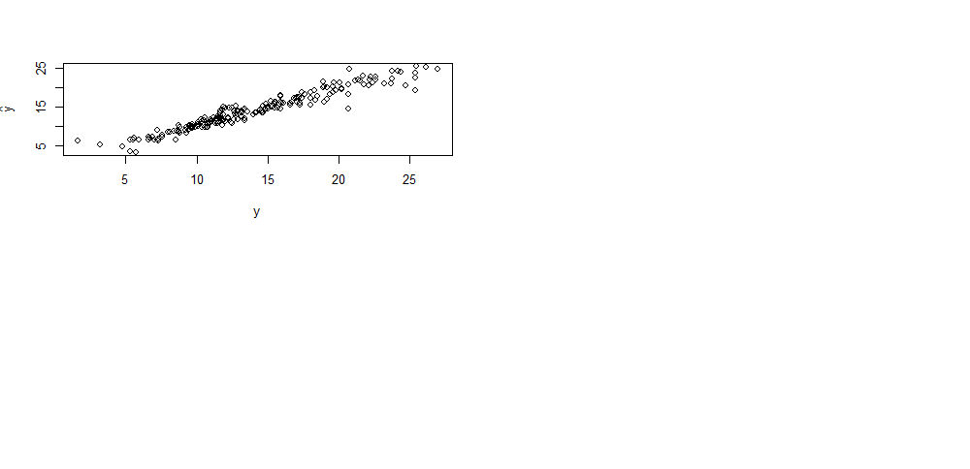> var(ad.knn$pred)/var(Advertising$Sales)

[1] 0.8836245

> y=Advertising$Sales

> yhat=ad.knn$pred

> rsq=1-sum((y-yhat)^2)/sum((y-mean(y))^2);rsq

[1] 0.9310732

> cor(yhat,y)^2 #approximate rsq very well.

[1] 0.931805

# Comparable to (ad.lm)?

> yhat2=predict(ad.lm,Advertising)

> plot(Advertising$Sales,yhat2,xlab="y",ylab=expression(hat(y)))

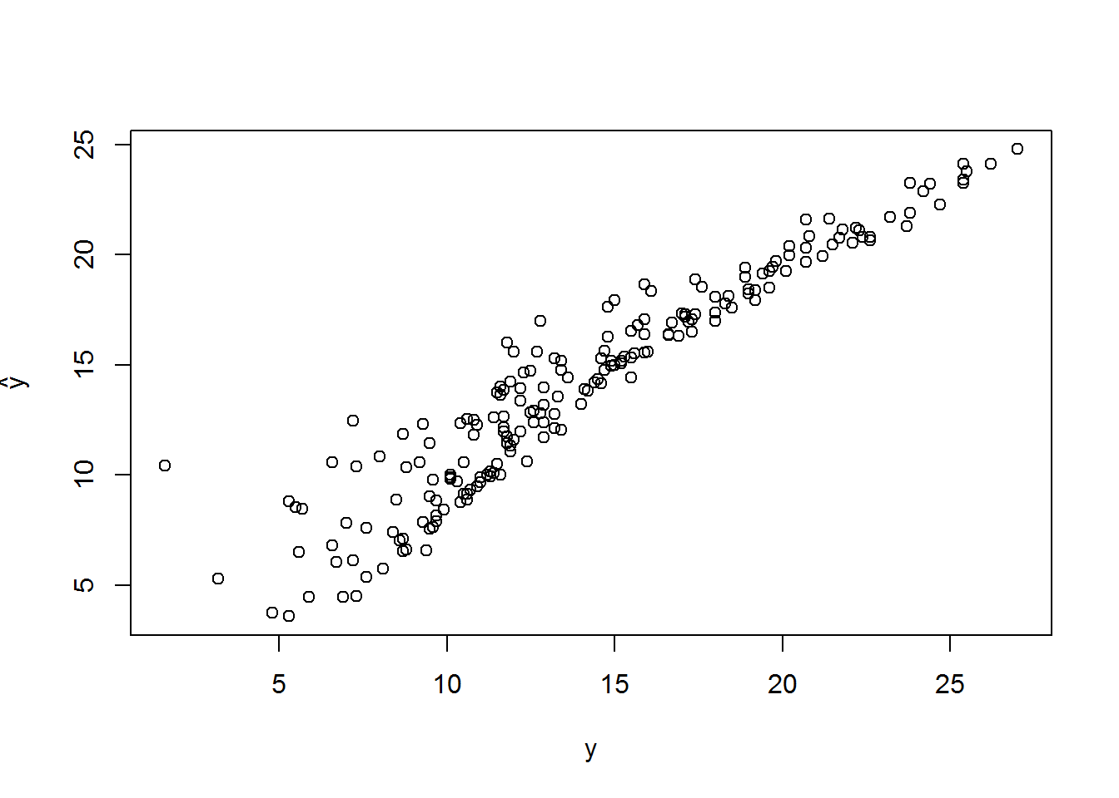

> rsq2=1-sum((y-yhat2)^2)/sum((y-mean(y))^2);rsq2

[1] 0.8972106

>

> cor(yhat2,y)^2 #approximate rsq very w

[1] 0.8972106

>

> dim(Advertising)

[1] 200 4

>

> train <- sample(1:dim(Advertising)[1],.7*dim(Advertising)[1])

> test=-train

>

> train.Ad <- Advertising[train,]

> test.Ad <- Advertising[test,]

> lm.tr <- lm(Sales ~., data=train.Ad)

> summary(lm.tr)

Call:

lm(formula = Sales ~ ., data = train.Ad)

Residuals:

Min 1Q Median 3Q Max

-4.9750 -0.7196 0.2169 1.0719 2.7066

Coefficients:

Estimate Std. Error t value Pr(>|t|)

(Intercept) 3.019619 0.347545 8.688 1.03e-14 ***

TV 0.046931 0.001534 30.598 < 2e-16 ***

Radio 0.185071 0.009594 19.290 < 2e-16 ***

Newspaper -0.004039 0.006734 -0.600 0.55

---

Signif. codes: 0 ‘***’ 0.001 ‘**’ 0.01 ‘*’ 0.05 ‘.’ 0.1 ‘ ’ 1

Residual standard error: 1.518 on 136 degrees of freedom

Multiple R-squared: 0.9138, Adjusted R-squared: 0.9119

F-statistic: 480.3 on 3 and 136 DF, p-value: < 2.2e-16

**Asumsi**

> View(advertising)

> data("advertising")

Warning message:

In data("advertising") : data set ‘advertising’ not found

> model_advertising=lm(Sales ~ TV + Radio + Newspaper, data = advertising)

> summary(model_advertising)

Call:

lm(formula = Sales ~ TV + Radio + Newspaper, data = advertising)

Residuals:

Min 1Q Median 3Q Max

-8.8277 -0.8908 0.2418 1.1893 2.8292

Coefficients:

Estimate Std. Error t value Pr(>|t|)

(Intercept) 2.938889 0.311908 9.422 <2e-16 ***

TV 0.045765 0.001395 32.809 <2e-16 ***

Radio 0.188530 0.008611 21.893 <2e-16 ***

Newspaper -0.001037 0.005871 -0.177 0.86

---

Signif. codes: 0 ‘***’ 0.001 ‘**’ 0.01 ‘*’ 0.05 ‘.’ 0.1 ‘ ’ 1

Residual standard error: 1.686 on 196 degrees of freedom

Multiple R-squared: 0.8972, Adjusted R-squared: 0.8956

F-statistic: 570.3 on 3 and 196 DF, p-value: < 2.2e-16

> hist(advertising$TV)

> plot(Sales~TV,data=advertising)

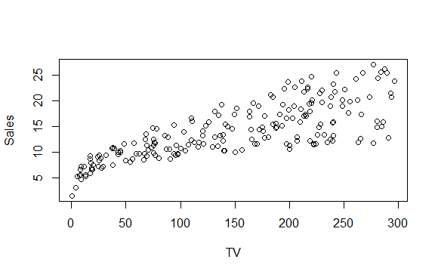

> ols_correlations(model_advertising)

Correlations

--------------------------------------------

Variable Zero Order Partial Part

--------------------------------------------

TV 0.782 0.920 0.751

Radio 0.576 0.842 0.501

Newspaper 0.228 -0.013 -0.004

--------------------------------------------

1. **Normalitas**

> ols_plot_resid_qq(model_advertising)

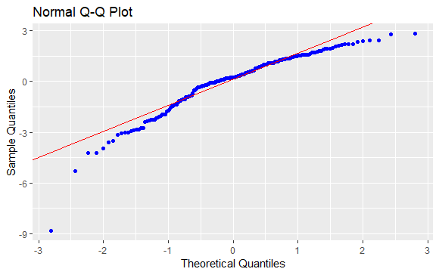

> ols_test_normality(model)

-----------------------------------------------

Test Statistic pvalue

-----------------------------------------------

Shapiro-Wilk 0.9453 0.1059

Kolmogorov-Smirnov 0.1028 0.8537

Cramer-von Mises 2.521 0.0000

Anderson-Darling 0.4537 0.2535

1. **Heteroskedastisitas**

H0: ${σ_{1}}^{2}$ = ${σ_{1}}^{2}$ =… = ${σ_{N}}^{2}$ = ${σ_{ε}}^{2}$ = $σ^{2}$ (Ragam sisaan homogen)

H1: ${σ_{i}}^{2}$ = c ${X_{i}}^{2}$ (Ragam sisaan tidak homogen atau heterogen)

> lmtest::bptest(model_advertising)

studentized Breusch-Pagan test

data: model_advertising

BP = 5.1329, df = 3, p-value = 0.1623

**3. Autokorelasi**

dwtest(model_advertising)

Durbin-Watson test

data: model_advertising

DW = 2.0836, p-value = 0.7236

alternative hypothesis: true autocorrelation is greater than 0

alternative hypothesis: true autocorrelation is greater than 0

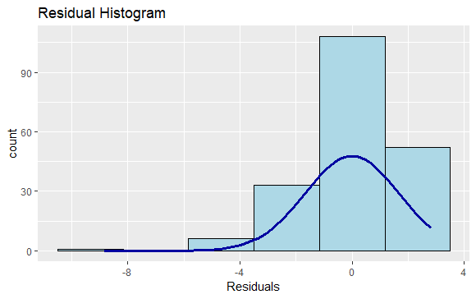ols_plot_resid_hist(model_advertising)

**4. MULTICOLONIERITAS**

> ols_vif_tol(model_advertising)

# A tibble: 3 x 3

Variables Tolerance VIF

*<chr>* *<dbl>* *<dbl>*

1 TV 0.995 1.00

2 Radio 0.873 1.14

3 Newspaper 0.873 1.15